Existential Philosophy
PHIL 224 Summer Session II

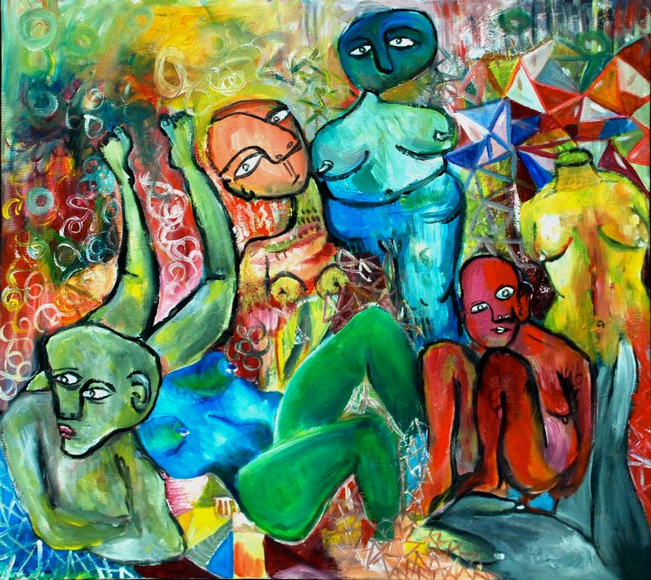
Art By Tamara Fakhoury

Existentialism considers how to find meaning, live ethically, and conceive of ourselves as human beings though the world appears meaningless and absurd. We will be discussing themes such as authenticity, absurdity, nihilism, and meaning in life and how social norms and constraints, colonialism, and the question of the existence of god impact our answers and approach to these issues. We will be using fiction and films as well as philosophical texts. As if that weren’t enough, there are a lot of funny comics about Existentialism on the internet.
Students should feel free to contact the instructor at lhtownse@live.unc.edu with questions or suggestions.

This course has no pre-requisites and fulfills the Philosophical/Moral Reasoning and North Atlantic World requirements.

